SUDENT’S HANDOUT MVC EXERCISE2

Welcome to the MVC in ASP.NET Core training session on creating a job portal application! This handout provides guidelines for students on how to approach the material, participate in workshops, and complete exercises. This Topic Includes Creating View ,Controller ,Dependency Injections and other functionalities..

Create a Company controller to perform Company Registrations,Company Profile,Company Member Registration,Company Member Listing,Remove Company Member

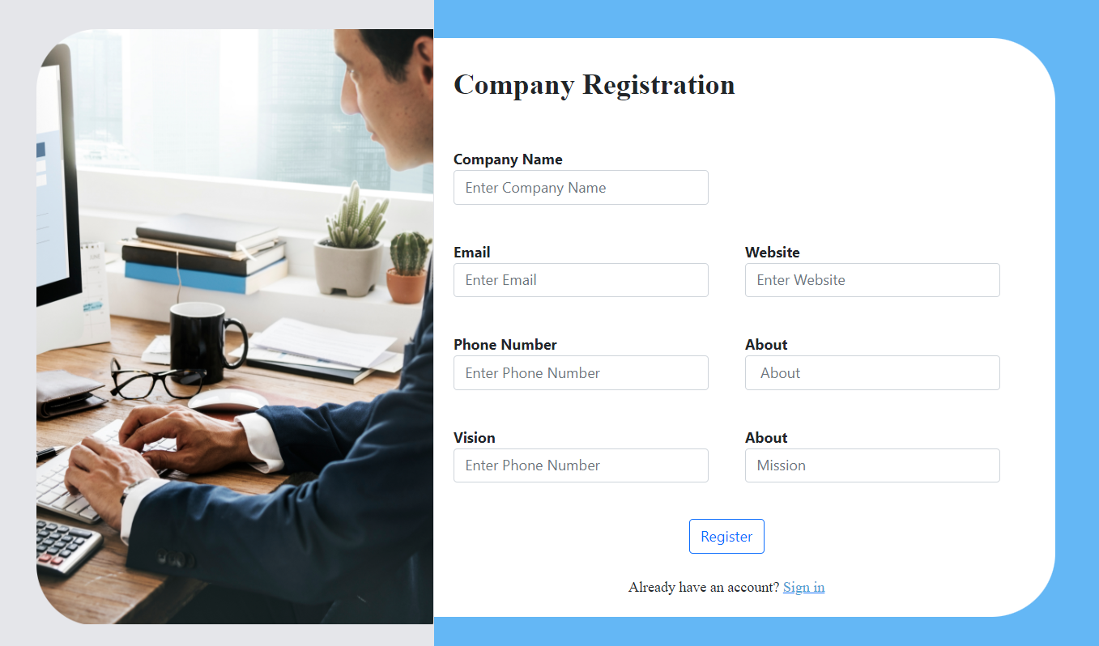

**Company Profile:**

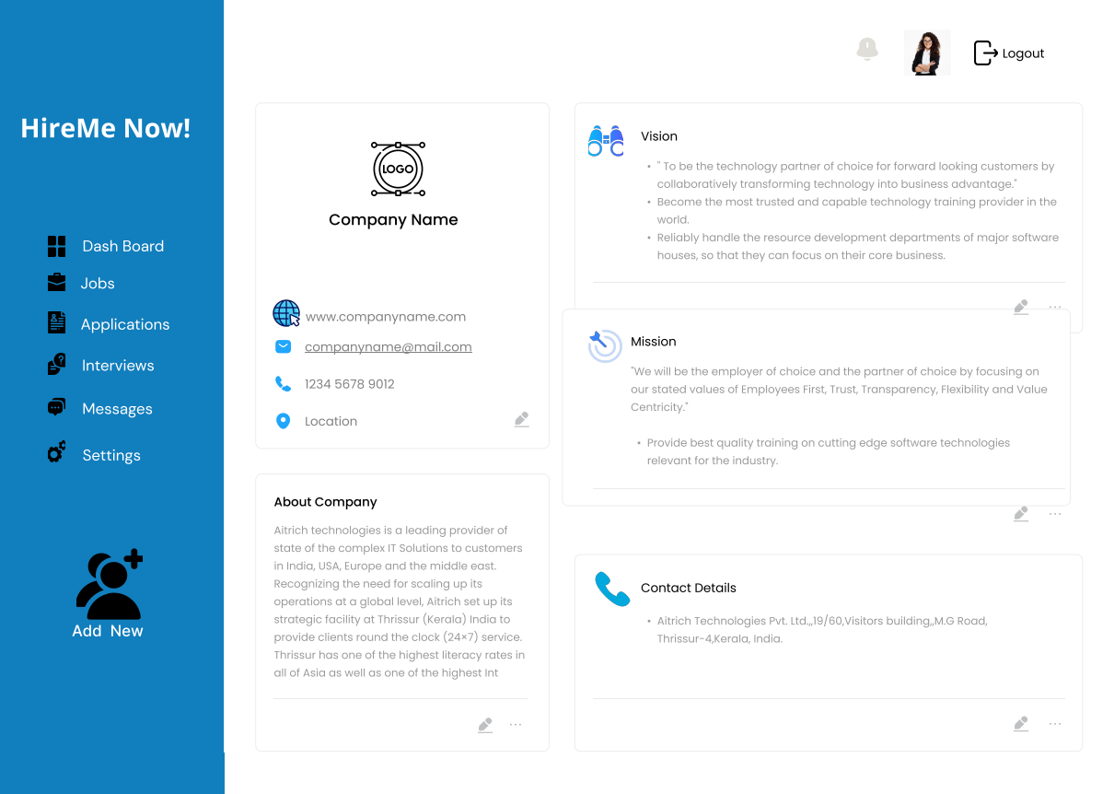

**Company Member Register**

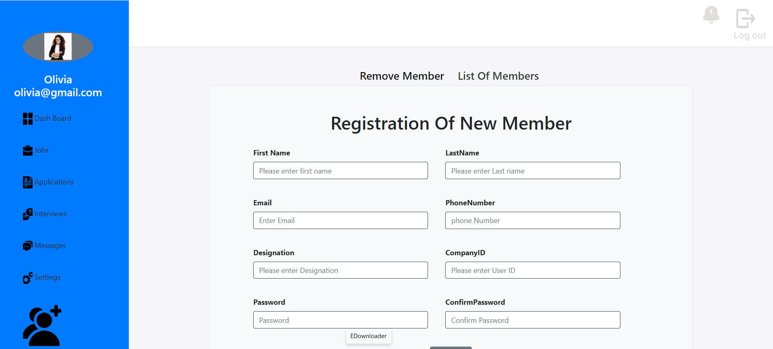

**Remove Company Member**

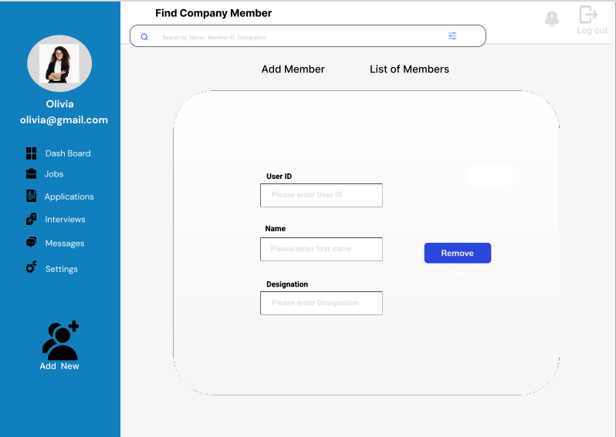

**Company Member Listing**

